**ASSIGNMENT-3**

Create and design a social media advertisement poster using Canva.

|  |  |
| --- | --- |
| NAME | S.SATHISH |
| NM ID | D3AB4E60998F2BBA802428A0FF7D9B00 |
| ASSIGNMENT 3 | Create and design a social media advertisement poster using Canva |

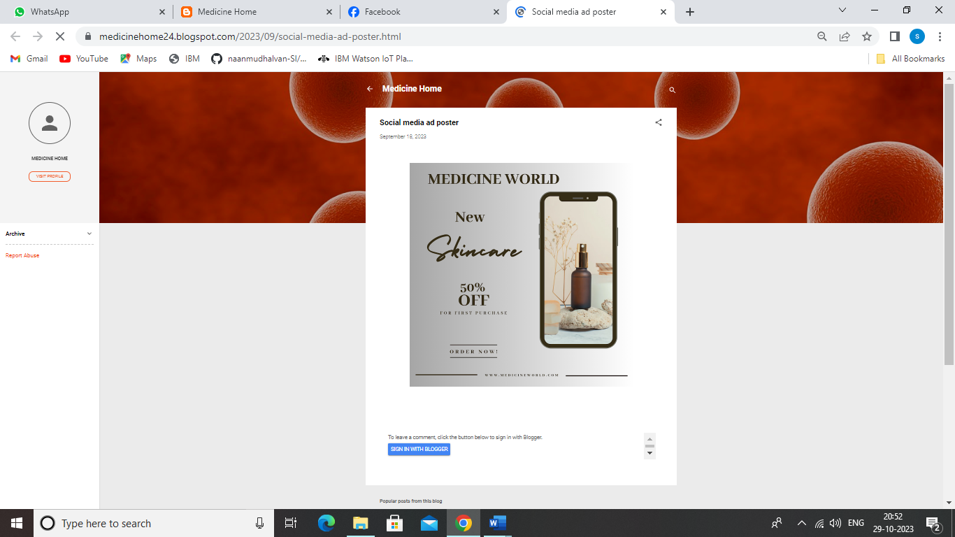

**SOCIAL MEDIA AD POSTER LINK:**

[**https://medicinehome24.blogspot.com/2023/09/social-media-ad-poster.html**](https://medicinehome24.blogspot.com/2023/09/social-media-ad-poster.html)